**Object-Oriented Design Document for MTT Client Configuration File Editor**

**Part 1: Architectural Design**

**Prepared for Master of Software Engineering Capstone Project**

**Advisor: Joshua Hursey**

**Student: Han Chen**

**Date: May 11, 2015**

**1. About this document**

This document describes the architectural design of the software for MTT client configuration file editor. The requirements for this software are given in [1,2]. The architectural design includes a conceptual object-oriented view (described in UML notation) and a data view (described in ERD notation).

**2. Conceptual View**

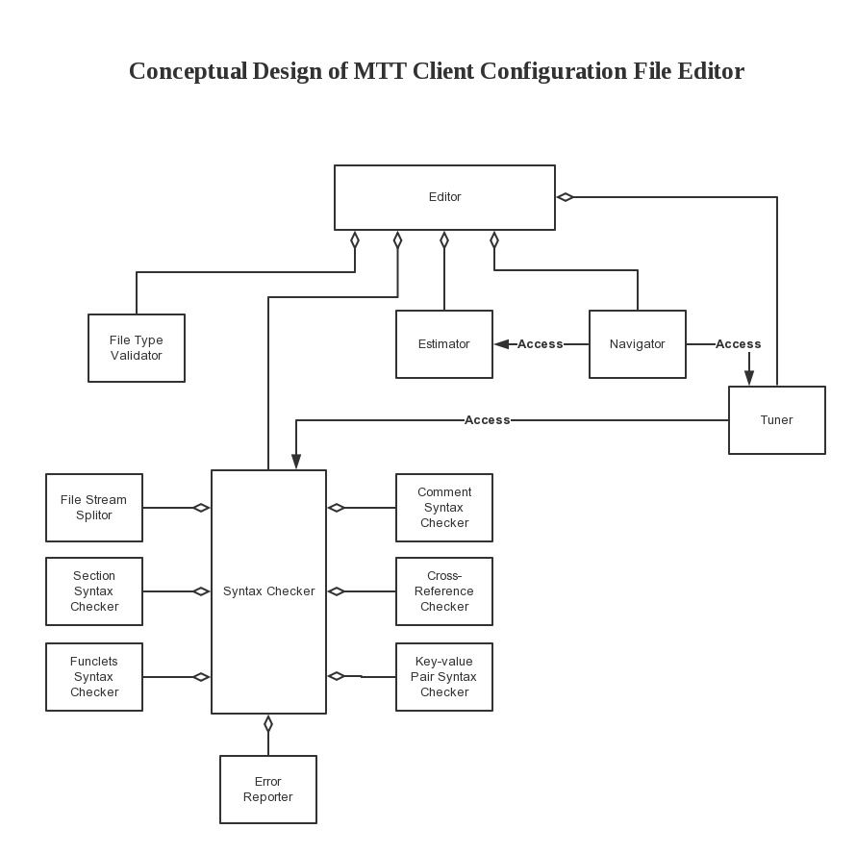

**3. Data View**

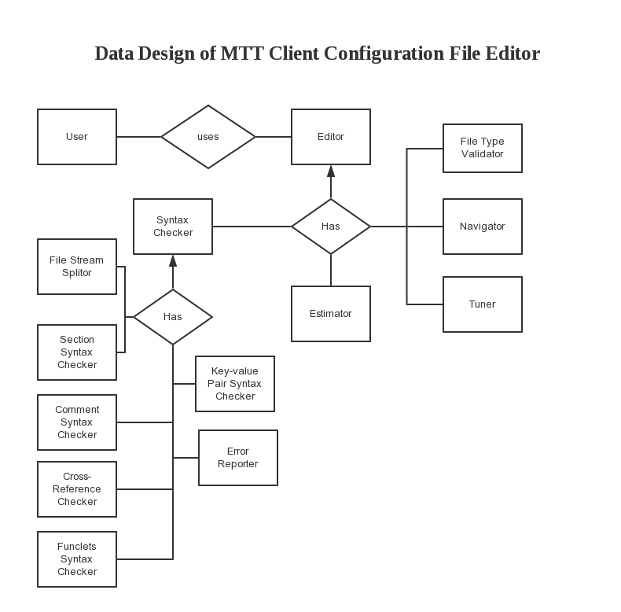

**References**

1. Han Chen, “Software Requirements Document for MTT Client Configuration File Editor – Part 1: Product Overview and Assumptions”, May 2015.
2. Han Chen, “Software Requirements Document for MTT Client Configuration File Editor – Part 2: Functional Requirement”, May 2015.